-Job - 6
Practical 1: Basic Document Formatting
Aim: To create a document using functions like Save As, Page Number, and Bullets and Numbering.
Software Required: MS-Word
Procedure:
- Open MS-Word and type a few paragraphs of text.
- To Save As:
  - Click on the File menu, then select Save As.
  - Browse to a desired location on your computer.
  - Enter a new File name for the document (e.g., "Practical-1").
  - Select the Save as type (e.g., Word Document *.docx) and click Save.
- To Insert Page Numbers:
  - Go to the Insert tab.
  - In the Header & Footer group, click on Page Number.
  - Choose a position for the page number (e.g., Bottom of Page) and select a style. The page numbers will be automatically added to each page.
- To Apply Bullets and Numbering:
  - Type a list of items.
  - Select the list.
  - Go to the Home tab. In the Paragraph group, click the Bullets icon to apply bullet points or the Numbering icon for a numbered list.
Output: A new Word document is created and saved with a specific name. It contains text formatted with bullet points and has page numbers at the bottom of each page.
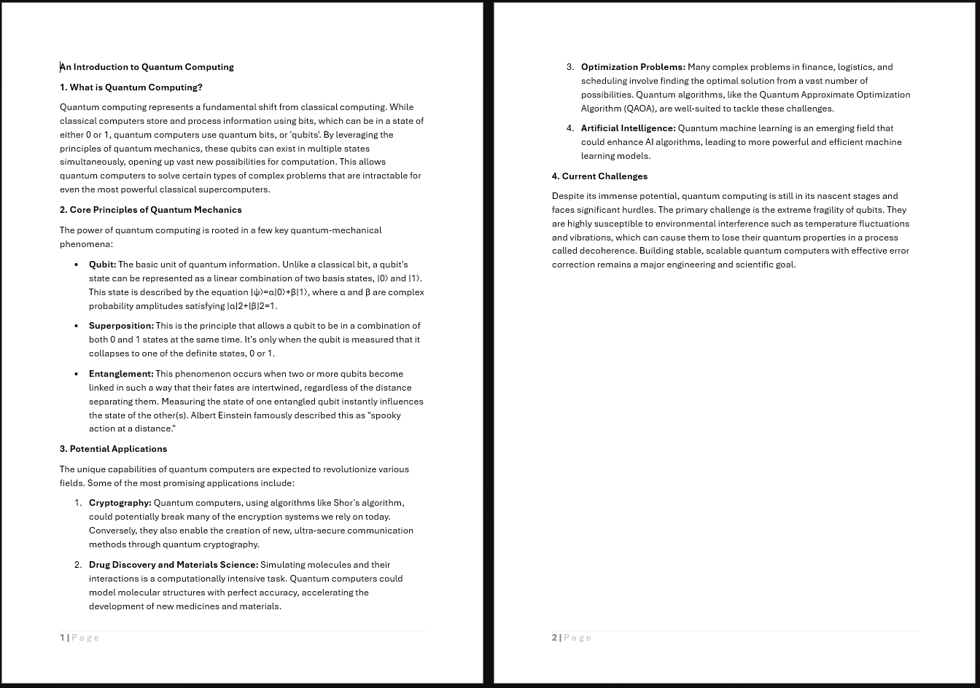
Figure 1 Basic Document Formatting
Practical 2: Advanced Formatting
Aim: To create a document using various fonts, styles, and formatting options.
Software Required: MS-Word
Procedure:
- Open a new MS-Word document and type some text, including headings and paragraphs.
- To Change Fonts:
  - Select the text you want to modify.
  - On the Home tab, go to the Font group.
  - Choose a new font from the dropdown menu (e.g., Times New Roman, Arial).
  - Adjust the font size, colour, and apply effects like Bold, Italic, or Underline.
- To Apply Styles:
  - Select a heading in your document.
  - On the Home tab, go to the Styles gallery.
  - Click on a style like Heading 1 or Heading 2. This applies a pre-defined set of formatting for consistency.
- To Use Other Formatting Options:
  - Select a paragraph.
  - In the Paragraph group on the Home tab, change the alignment (Left, Centre, Right, Justify).
  - Adjust the Line and Paragraph Spacing.
Output:

Figure 2 Advanced Formatting

Practical 3: Page Background and Layout
Aim: To create a document using Fill Effects, Watermark, Header, and Footer.
Software Required: MS-Word
Procedure:
- Open a new MS-Word document.
- To Add a Watermark:
  - Go to the Design tab.
  - In the Page Background group, click Watermark.
  - Choose a default watermark or select Custom Watermark to use your own text or an image.
- To Add Page Colour (Fill Effect):
  - On the Design tab, click Page Colour.
  - Select a solid colour, or click Fill Effects to apply gradients, textures, or patterns.
Figure 3 Applying Page Colour and Watermark
- To Use Header and Footer:
  - Go to the Insert tab.
  - In the Header & Footer group, click Header. Select a style and type your header text.
  - Click Footer, select a style, and type your footer text.
  - Click Close Header and Footer.
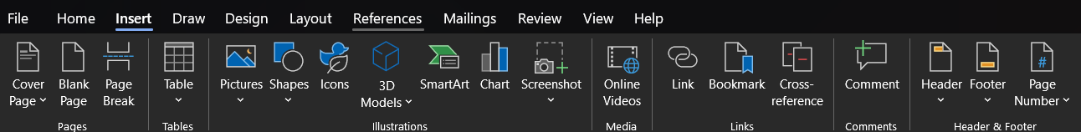
Figure 4 Inserting Header and Footer
Output: 
Figure 5 Header, Page Border, Page Colour and Watermark

Figure 6 Footer

Practical 4: Page Setup and Printing
Aim: To set up the page layout of a document, preview it, and print it.
Software Required: MS-Word
Procedure:
- Create or open a document in MS-Word.
- To Set Up the Page:
  - Go to the Layout tab.
  - In the Page Setup group, click Margins and select an option (e.g., Normal, Narrow).
  - Click Orientation and choose Portrait or Landscape.
  - Click Size and select the paper size (e.g., A4, Letter).

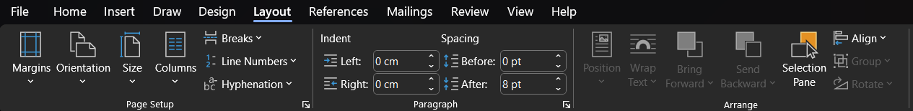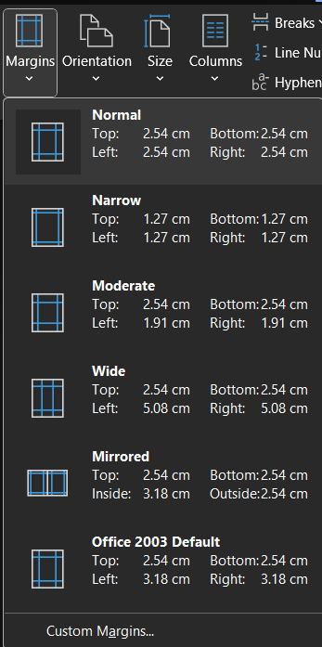
Figure 7 Document Margins

- To Preview the Document:
  - Go to File > Print.
  - The right-hand pane will show a full preview of how the document will appear when printed. You can use the arrows at the bottom to navigate through pages.
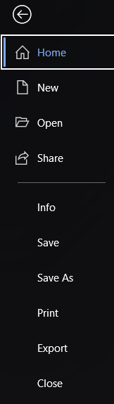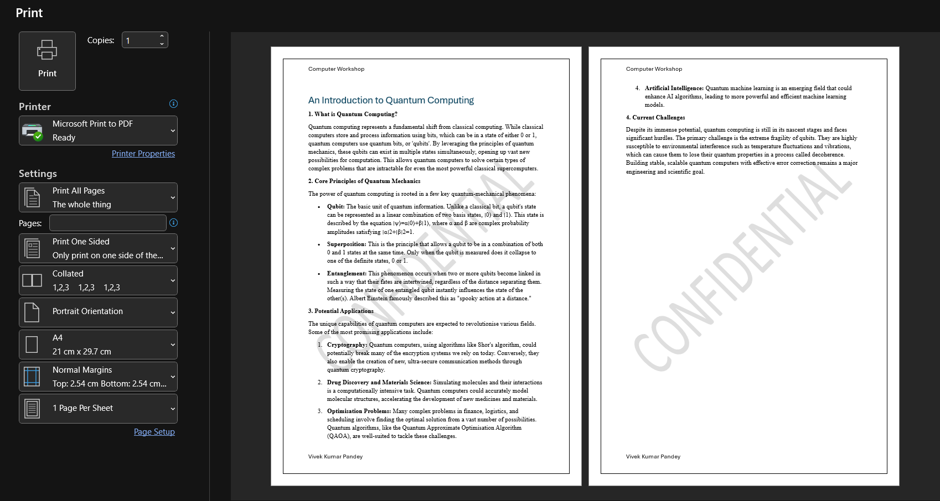
Figure 8 Print Preview
- To Print the Document:
  - In the File > Print menu, select the desired printer from the dropdown list.
  - Enter the number of copies.
  - Click the large Print button.

Output:

Figure 9 Narrow Margin
Practical 5: Mail Merge
Aim: To create personalised letters for multiple recipients using Mail Merge.
Software Required: MS-Word, MS-Excel (for data source)
Procedure:
- First, create a simple data source in MS-Excel with columns First Name, Last Name, Email, etc. Save this file.
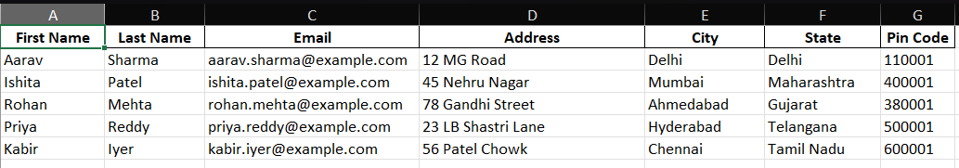
Figure 10 Sample Data for Mail Merge
- Open a new document in MS-Word and type the main body of the letter, leaving placeholders for personalised information.
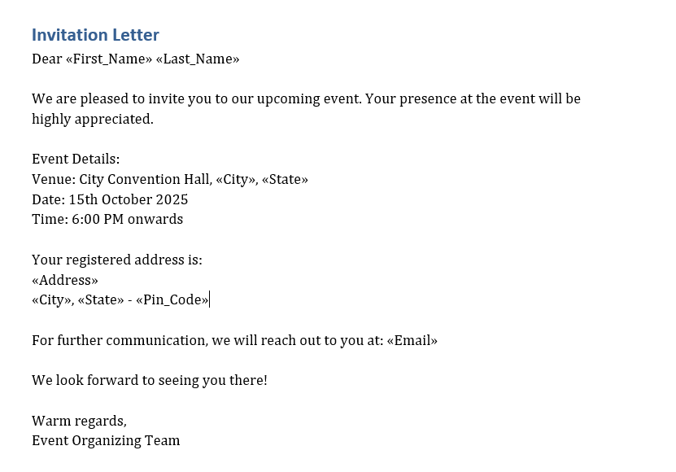
Figure 11 Invitation Template
- Go to the Mailings tab and click Start Mail Merge > Letters.
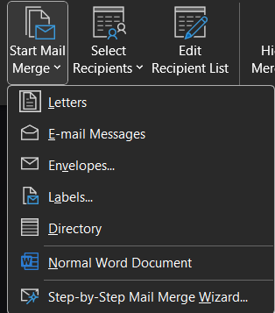
Figure 12 Starting Mail Merge
- Click Select Recipients > Use an Existing List.... Browse and select the Excel file you created.
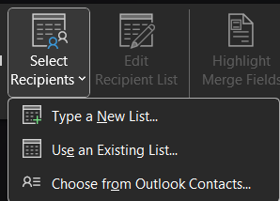
Figure 13 Inserting the guest list

- Place your cursor where you want to add personalised data (e.g., after "Dear").
- Click Insert Merge Field and select a field. The placeholder’s ‘Name’ will appear.
- Repeat this for all other fields (City, State, etc.).
- Click Preview Results to see how the letter looks with actual data from your list.
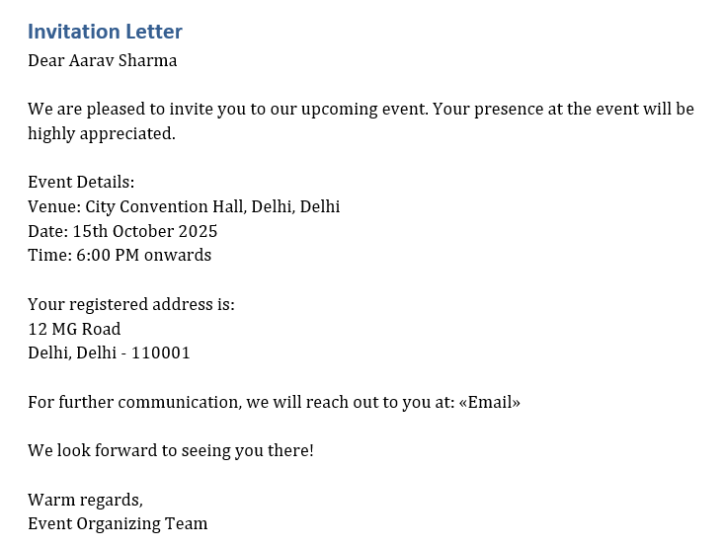
Figure 14 Letter Preview
- Finally, click Finish & Merge > Edit Individual Documents to create a new Word file containing all the personalised letters.
Practical 6: Using Macros
Aim: To record and run a macro in MS-Word to automate a repetitive task.
Software Required: MS-Word
Procedure:
- First, enable the Developer tab by Going to File > Options > Customize Ribbon and checking the box for Developer.
- Go to the view tab and click Record Macro.
- Give your macro a name (e.g., "Header Format") and click OK. The mouse pointer will change, indicating that recording has started.
- Perform the sequence of actions to be automated. For example:
  - Go to the Home tab.
  - Change the font to 'Arial', size to '14', and apply Bold and Underline.
  - Centre align the text.
- Go back to the Developer tab and click Stop Recording.
- To run the macro, type a new line of text, select it, go to the Developer tab, click Macros, select "Header Format", and click Run.
Output:
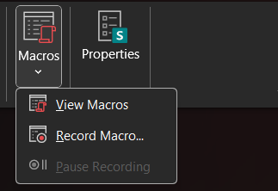
Figure 15 Recording Macro
s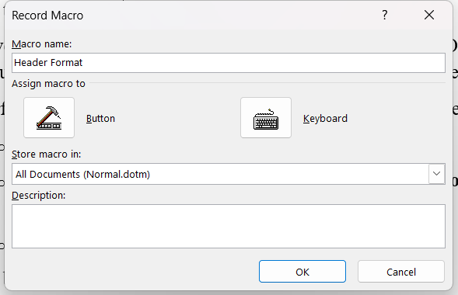
Figure 16 Naming Macro

Practical 7: Working with Tables
Aim: To create a table and perform operations like Insert, Delete, Select, and apply AutoFormat.
Software Required: MS-Word
Procedure:
- To Create a Table:
  - Go to the Insert tab, click Table, and drag your cursor over the grid to select the desired number of rows and columns.
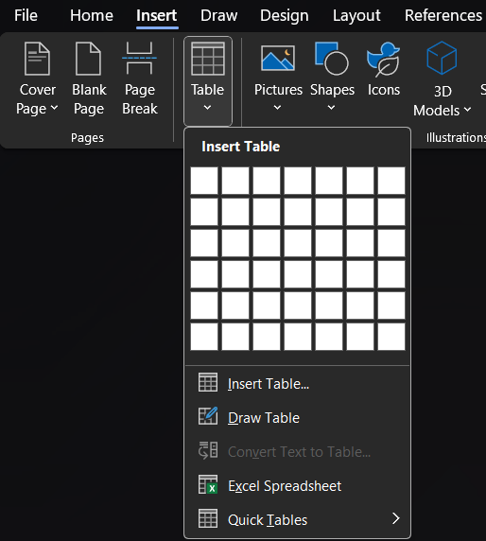
Figure 17 Inserting a table
- To Select:
  - To select a cell, click inside it.
  - To select a row, move the cursor to the left of the row and click.
  - To select a column, move the cursor to the top of the column until it becomes a down arrow, and click.
- To Insert/Delete:
  - Right-click on a cell within the table.
  - From the context menu, choose Insert to add rows or columns.
  - Choose Delete Cells to remove cells, rows, or columns.
- To AutoFormat (Apply Table Styles):
  - Click anywhere inside the table.
  - Two new tabs, Table Design and Layout, will appear.
  - On the Table Design tab, choose a pre-designed style from the Table Styles gallery.
Output:
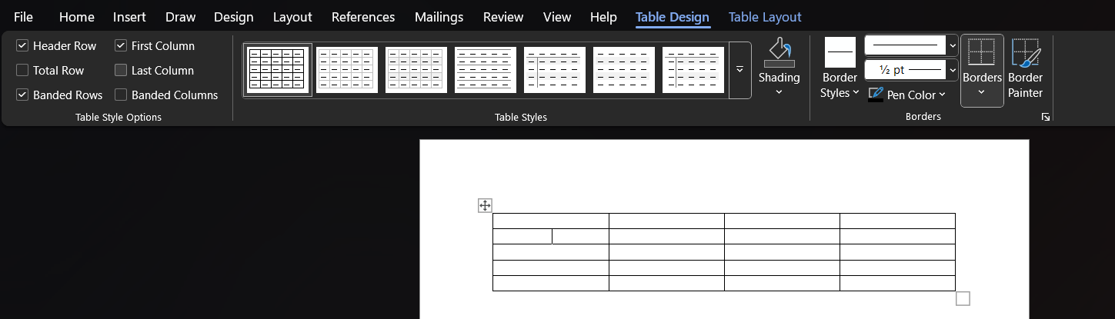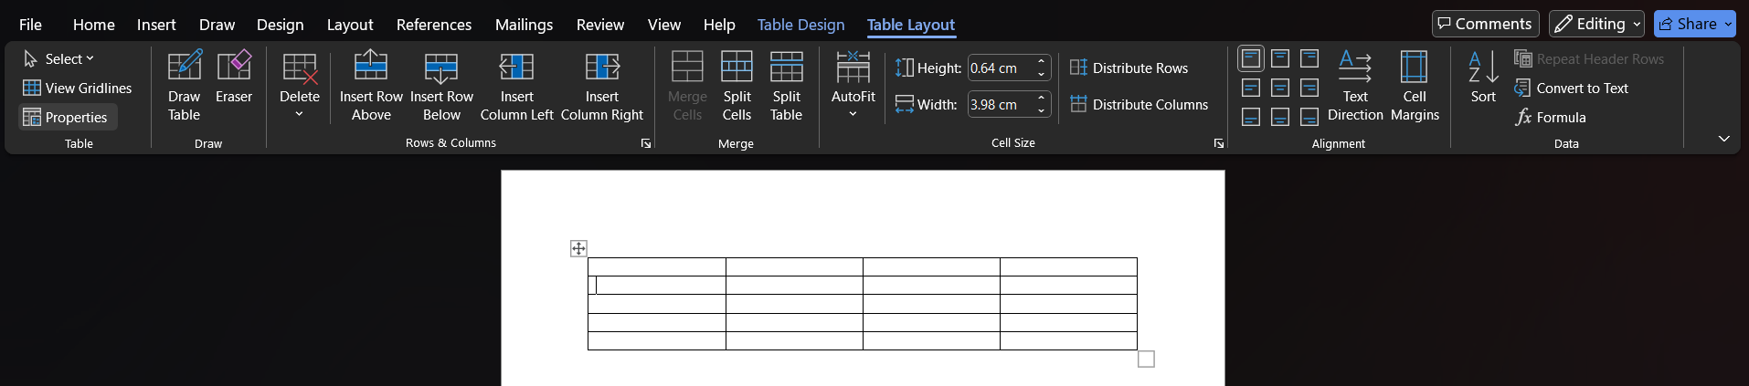
MS-Excel Practicals
Practical 8: Creating Charts
Aim: To create Line, XY, Bar, and Pie charts to compare and visualise data.
Software Required: MS-Excel
Procedure:
- Enter your data in two columns. For example, Column A for "Month" and Column B for "Sales".
- Select the entire data range, including the headers.
- Go to the Insert tab.
- To create a Bar Chart:
  - In the Charts group, click Insert Column or Bar Chart and select a 2-D or 3-D Bar chart.
- To create a Line Chart:
  - Click Insert Line or Area Chart and select a style.
- To create a Pie Chart:
  - Click Insert Pie or Doughnut Chart and select a style. (Note: Pie charts are best for data representing parts of a whole).
- To create an XY (Scatter) Chart:
  - This requires two numerical columns. Click Insert Scatter (X, Y) or Bubble Chart.
- Once a chart is created, you can customise its Chart Title, Axis Titles, and colours using the Chart Design tab.
Output:

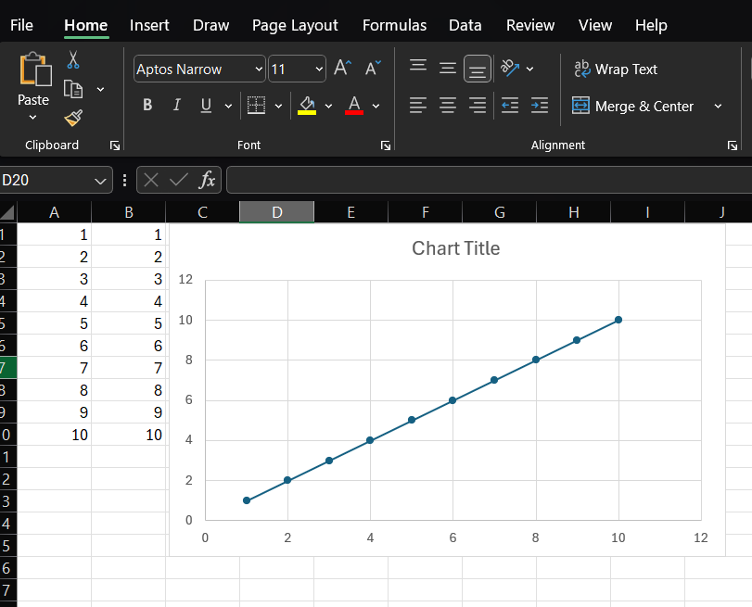
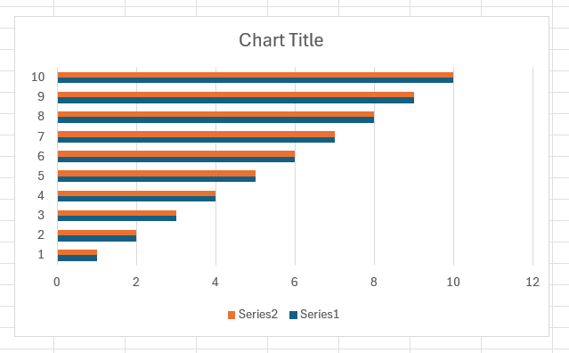
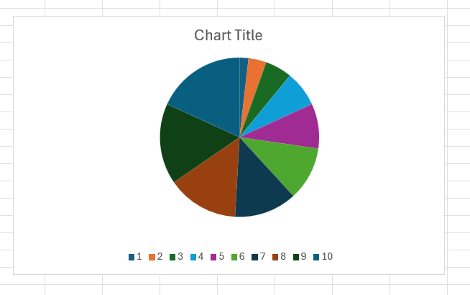
Practical 9: Using Formulas
Aim: To implement basic mathematical formulas (Addition, Subtraction, Multiplication, Division) in Excel.
Software Required: MS-Excel
Procedure:
- Enter numbers into different cells (e.g., 100 in cell A1 and 50 in cell B1).
- Addition: In cell C1, type the formula =A1+B1 and press Enter.
- Subtraction: In cell C2, type =A1-B1 and press Enter.
- Multiplication: In cell C3, type =A1*B1 and press Enter.
- Division: In cell C4, type =A1/B1 and press Enter.
- SUM Function: To add a range of numbers (e.g., A1 to A5), go to an empty cell and type =SUM (A1:A5) and press Enter.
Output:
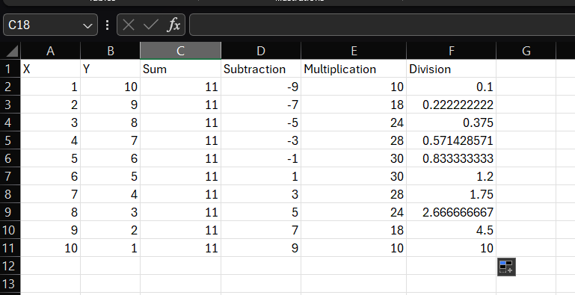

Practical 10: Using Macros in Excel
Aim: To use a macro to automate tasks in MS-Excel.
Software Required: MS-Excel
Procedure:
- Enable the Developer tab (File > Options > Customize Ribbon > check Developer).
- Click on the Developer tab and select Record Macro.
- Enter a name for the macro (e.g., "Apply Formatting") and click OK.
- Perform the actions to be recorded. For example, select a cell and:
  - Go to the Home tab.
  - Change the background fill colour to Yellow.
  - Make the font Bold.
  - Apply a border around the cell.
- Go to the Developer tab and click Stop Recording.
- To test the macro, select a new cell or a range of cells. Go to Developer > Macros, select your macro, and click Run.
Output:
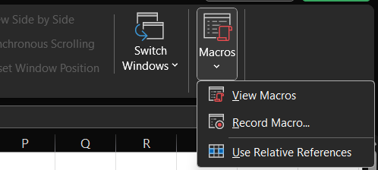
+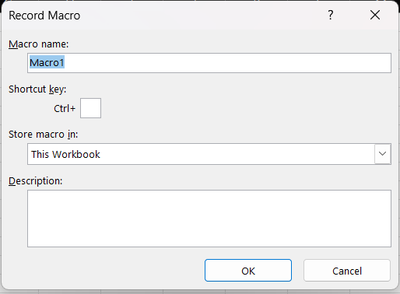
Practical 11: Sorting, Filtering, and Hyperlinking
Aim: To use the concepts of sorting, filtering, and hyperlinking in Excel.
Software Required: MS-Excel
Procedure:
- Create a table of data with headers (e.g., Name, Age, City).
- To Sort Data:
  - Select the entire table.
  - Go to the Data tab and click Sort.
  - In the dialogue box, choose the column to Sort by (e.g., Name) and the Order (A to Z). Click OK.
- To Filter Data:
  - Select the header row of your table.
  - Go to the Data tab and click Filter.
  - Dropdown arrows will appear next to each header. Click the arrow for a column (e.g., City) and check only the values you want to see.
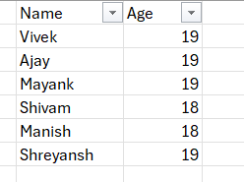
- To Add a Hyperlink:
  - Right-click on a cell where you want to add a link.
  - Select Link.
  - In the dialogue box, you can link to an Existing File or Web Page by entering an address or link to a Place in This Document by selecting a cell reference. Click OK.
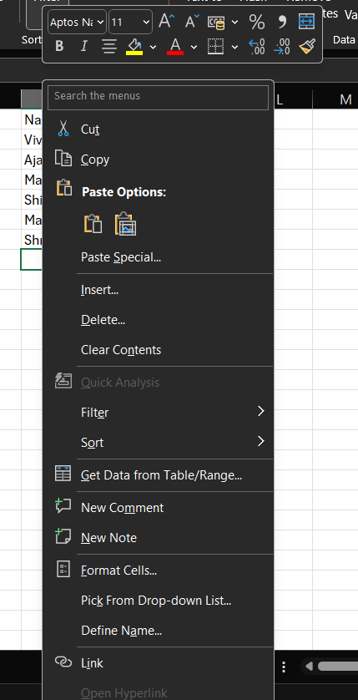

Practical 12: Paste Special and Paste as Hyperlink
Aim: To use the concept of Paste Special and Paste as Hyperlink in Excel.
Software Required: MS-Excel
Procedure:
- Enter a number in cell A1 (e.g., 50). In cell B1, enter a formula (e.g., =A1*2). Cell B1 will display 100.
- To use Paste Special:
  - Copy cell B1 (which contains the formula).
  - Right-click on cell C1 and select Paste Special.
  - In the dialogue box, select Values and click OK. Cell C1 will now display the number 100, but without the underlying formula.
  - You can also use Paste Special to paste only Formats or to perform operations like Add, Multiply, etc.
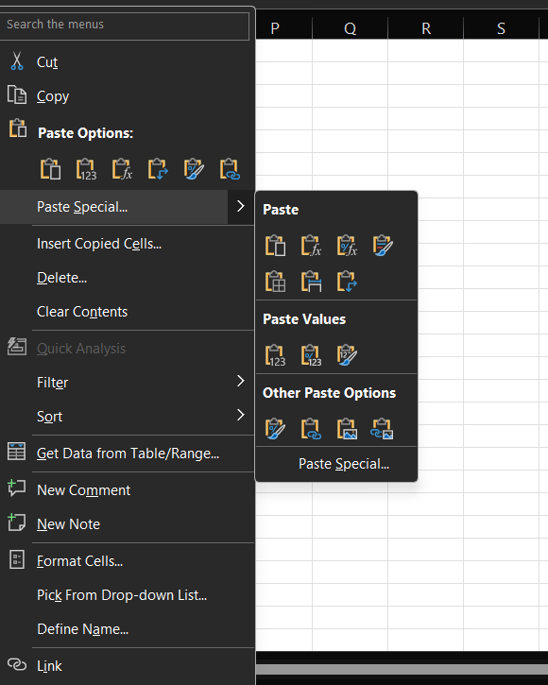
- To use Paste as Hyperlink:
  - Copy cell A1.
  - Right-click on cell D1 and choose the Paste as Hyperlink option (it may be under Paste Special options).
  - Cell D1 will now contain a link. Clicking it will take you to cell A1.
Output:
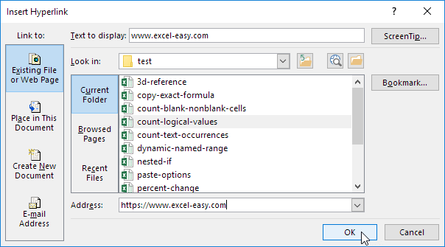
Practical 13: Advanced Cell Formatting
Aim: To create an Excel sheet using fonts, styles, formatting options, text wrap, and different row/column widths.
Software Required: MS-Excel
Procedure:
- Enter data into a new sheet.
- Fonts, Styles, and Formatting:
  - Use the Font group on the Home tab to change font type, size, and colour.
  - Use the Cell Styles option on the Home tab to apply pre-set styles (like Heading, Title, etc.).
- To Wrap Text:
  - Select a cell with a long sentence.
  - On the Home tab, in the Alignment group, click Wrap Text. The text will now be visible on multiple lines within the same cell.
- To Adjust Row/Column Width:
  - Move your cursor to the border between two column headers (e.g., between A and B) until it becomes a double-headed arrow, then click and drag to resize.
  - Alternatively, right-click a column header and select Column Width to enter a specific value. Do the same for rows by right-clicking the row number.
Output:
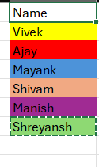
Practical 14: Comparing Values with Functions
Aim: To create a formula using a function to compare the values of two rows or columns.
Software Required: MS-Excel
Procedure:
- Enter numerical data in Column A and Column B.
- We will compare the value in cell A1 with the value in B1.
- In cell C1, we will use the IF function. The syntax is =IF(logical_test, [value_if_true], [value_if_false]).
- Type the following formula in cell C1: =IF(A1>B1, "A is Greater", "B is Greater or Equal").
- Press Enter. The cell will display the result based on the comparison.
- Click on the small square at the bottom-right of cell C1 (the fill handle) and drag it down to apply the formula to the rest of the rows.
Output:
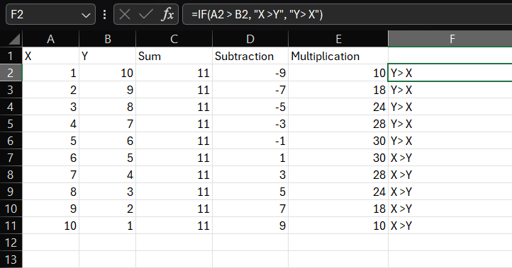
MS-PowerPoint Practicals
Practical 15: Presentation Design
Aim: To create a PowerPoint presentation using slide design, Design Templates, colour schemes, and Animation Schemes.
Software Required: MS-PowerPoint
Procedure:
- Open MS-PowerPoint and create a few slides with titles and content.
- To Apply a Design Template (Theme):
  - Go to the Design tab.
  - In the Themes gallery, click on any design to apply it to all slides.
- To Change Colour Schemes:
  - On the Design tab, to the right of the themes, is the Variants gallery.
  - Click the dropdown arrow to see different colour schemes for the selected theme. Select one.
- To Apply Animation Schemes:
  - Select an object on a slide (like a text box or image).
  - Go to the Animations tab.
  - Choose an animation effect from the gallery (e.g., Fly In, Fade, Wipe).
  - You can set the timing and order of animations using the Animation Pane.
Output:
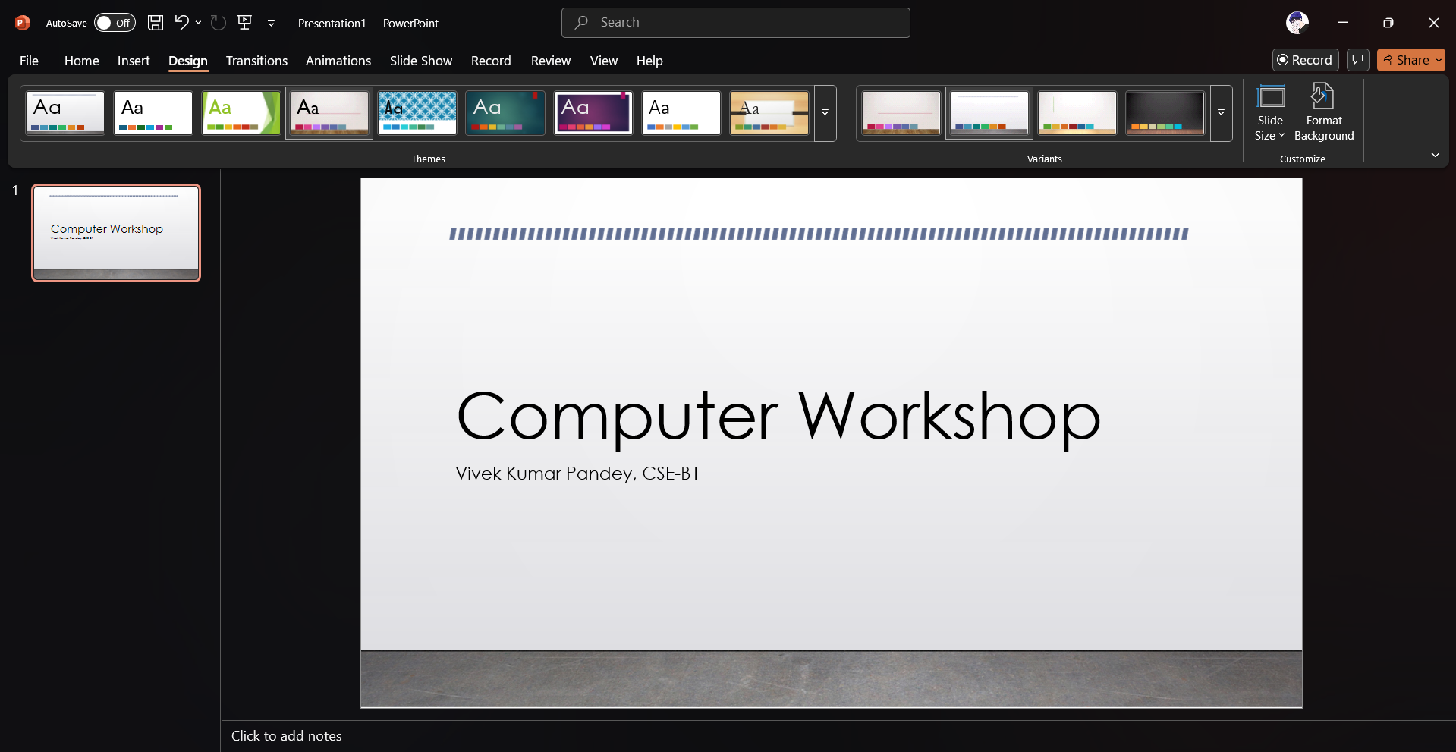
Practical 16: Presentation Setup and Printing
Aim: To create a presentation using functions like Save as, slide number, bullets and numbering, page setup, and print in layout form.
Software Required: MS-PowerPoint
Procedure:
- Create a presentation in PowerPoint.
- Save As, Bullets, Numbering: These functions work similarly to MS-Word.
- To Add Slide Numbers:
  - Go to the Insert tab and click Header & Footer.
  - Check the Slide number box. You can also add a Footer text.
  - Click Apply to All.
- To Set Page Setup (Slide Size):
  - Go to the Design tab.
  - Click Slide Size and choose Standard (4:3) or Widescreen (16:9).
- To Print in Layout Form:
  - Go to File > Print.
  - Under Settings, click the dropdown that says Full Page Slides.
  - In the Handouts section, select a layout, such as 3 Slides (which includes space for notes) or 6 Slides (to save paper).
  - Click Print.
Output:

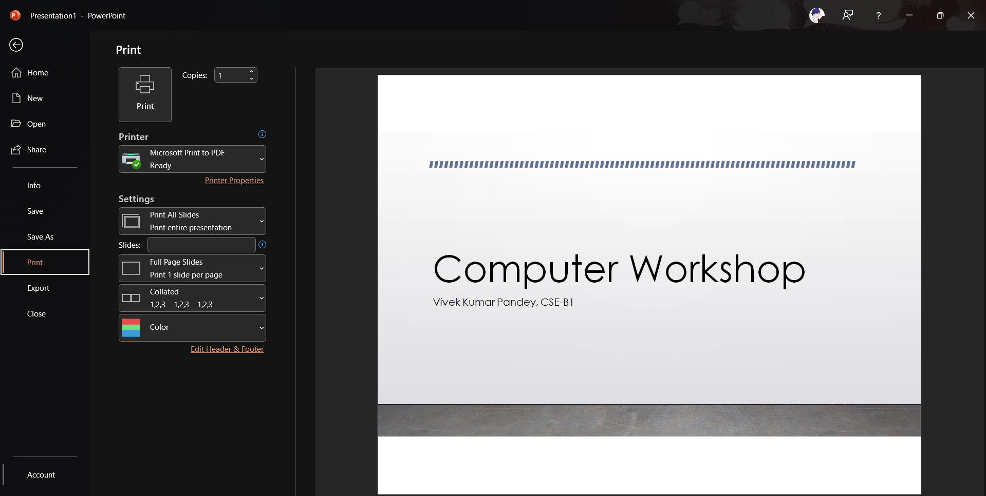
Practical 17: Using Multimedia and Effects
Aim: To create a PowerPoint presentation using clipart, WordArt, transitions, and animation effects.
Software Required: MS-PowerPoint
Procedure:
- Open a PowerPoint presentation.
- To Insert Clipart/Icons:
  - Go to the Insert tab and click Icons or Online Pictures. Search for an image and insert it.
- To Insert WordArt:
  - Go to the Insert tab and click WordArt.
  - Choose a style, type your text, and place it on the slide.
- To Add Transition Effects:
  - Select a slide you want to apply the transition to.
  - Go to the Transitions tab.
  - Choose an effect from the gallery (e.g., Push, Morph, Fade). This effect will play when you move to this slide during the show.
- To Add Animation Effects:
  - Select an object on the slide.
  - Go to the Animations tab and apply an effect as done previously.
Output:
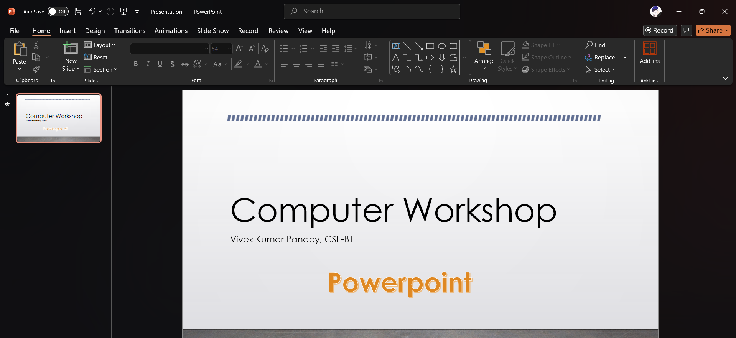
Practical 18: Using Macros in PowerPoint
Aim: To understand the concept of a macro in PowerPoint.
Software Required: MS-PowerPoint
Procedure:
- Enable the Developer tab (File > Options > Customize Ribbon).
- Go to the Developer tab and click Macros.
- Unlike Word and Excel, PowerPoint does not have a macro recorder. Macros must be written in the Visual Basic for Applications (VBA) editor.
- In the Macros dialogue box, type a name for a new macro (e.g., "InsertShape") and click Create.
- This will open the VBA editor. Here, you would write code to act. For example, to add a rectangle to the first slide, the code would be:
- Sub InsertShape()
- ActivePresentation.Slides(1).Shapes.AddShape(msoShapeRectangle, 50, 50, 100, 200)
- End Sub

- Close the VBA editor.
- To run the macro, go to Developer > Macros, select "InsertShape", and click Run.
Output:
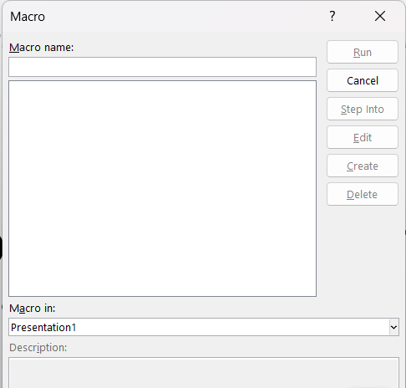

Practical 19: Using Charts, Diagrams, and Tables
Aim: To use charts, diagrams (SmartArt), and tables in a PowerPoint presentation.
Software Required: MS-PowerPoint
Procedure:
- Create a new slide and choose a Title and Content layout.
- To Insert a Table:
  - Click the Insert Table icon in the content placeholder, or go to Insert > Table. Specify the number of rows and columns.
- To Insert a Chart:
  - Click the Insert Chart icon in the placeholder, or go to Insert > Chart.
  - Select a chart type (e.g., Column). An Excel data sheet will pop up. Enter your data in this sheet to populate the chart.
- To Insert a Diagram (SmartArt):
  - Click the Insert a SmartArt Graphic icon in the placeholder, or go to Insert > SmartArt.
  - Choose a category (e.g., Process, Hierarchy) and a layout. Fill in the text for each shape in the diagram.
Output:
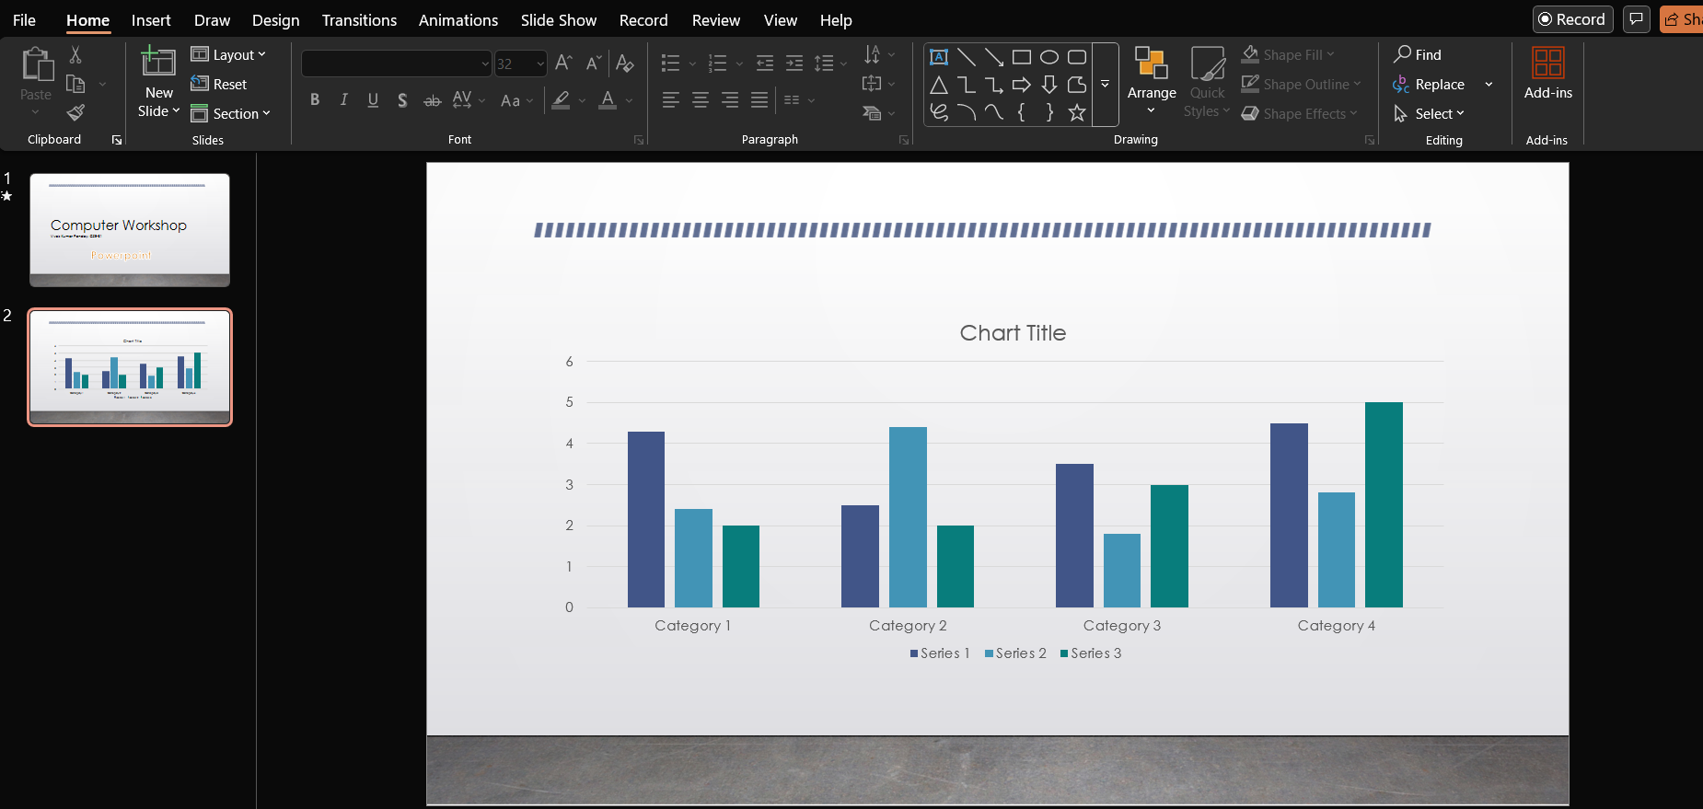
Practical 20: Presenter Tools
Aim: To use View Show, Setup Show, and Rehearse Timings in a presentation.
Software Required: MS-PowerPoint
Procedure:
- Finalise your presentation.
- To View Show:
  - Go to the Slide Show tab.
  - Click From Beginning to start the show from the first slide, or press the F5 key.
- To Set Up Show:
  - On the Slide Show tab, click Set Up Slide Show.
  - In the dialogue box, you can configure options like:
    - Show type: Presented by a speaker (full screen) or browsed at a kiosk (loop continuously).
    - Advance slides: Manually or using timings, if present.
  - Click OK.
- To Rehearse Timings:
  - On the Slide Show tab, click Rehearse Timings.
  - The presentation will start in full-screen mode with a recording timer at the top-left.
  - Speak and advance through your slides as if you were presenting. PowerPoint will record the time you spend on each slide.
  - At the end, you will be asked if you want to save these timings. Click Yes.
Output:
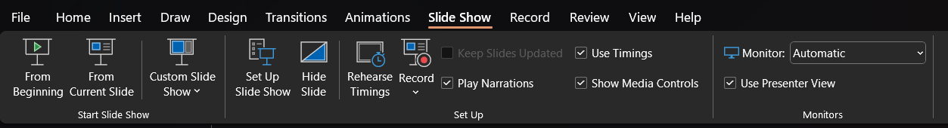
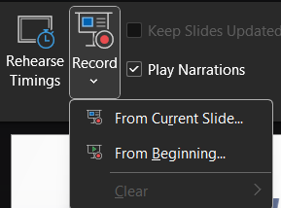

MS-Access Practicals
Practical 21: Creating Forms
Aim: To create a form in MS-Access for easy data viewing and entry.
Software Required: MS-Access
Procedure:
- First, create a table (e.g., "Employees") with fields like ID, Name, and City. Populate it with some data.
- In the left-hand Navigation Pane, click on the "Employees" table to select it.
- Go to the Create tab.
- In the Forms group, click the Form button.
- Access will instantly create a default form based on your selected table.
- You can view records using the navigation arrows at the bottom of the form. You can also edit data or add new records directly into the form fields.
- Save the form by pressing Ctrl + S and give it a name.
Output:
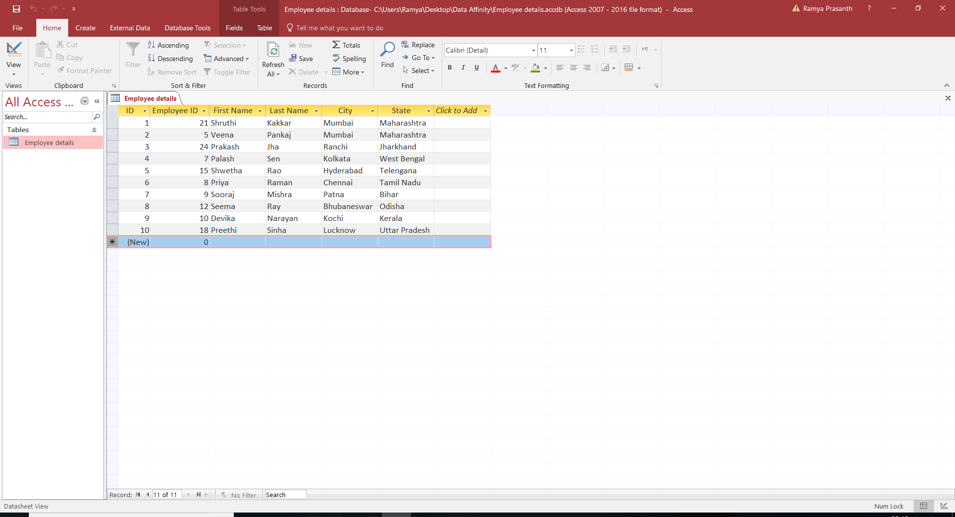
Practical 22: Creating Reports
Aim: To create a report in MS-Access to present data in a formatted, printable summary.
Software Required: MS-Access
Procedure:
- Select the table or query that contains the data you want in your report.
- Go to the Create tab.
- In the Reports group, click the Report button.
- Access will automatically generate a basic, columnar report based on the data source.
- You can switch to Layout View or Design View to modify the report's design, such as resizing fields, changing titles, and adding a logo.
- For a more guided approach, use the Report Wizard from the Create tab, which allows you to choose fields, grouping levels, and sorting options step-by-step.
- Save the report by pressing Ctrl + S.
Output:
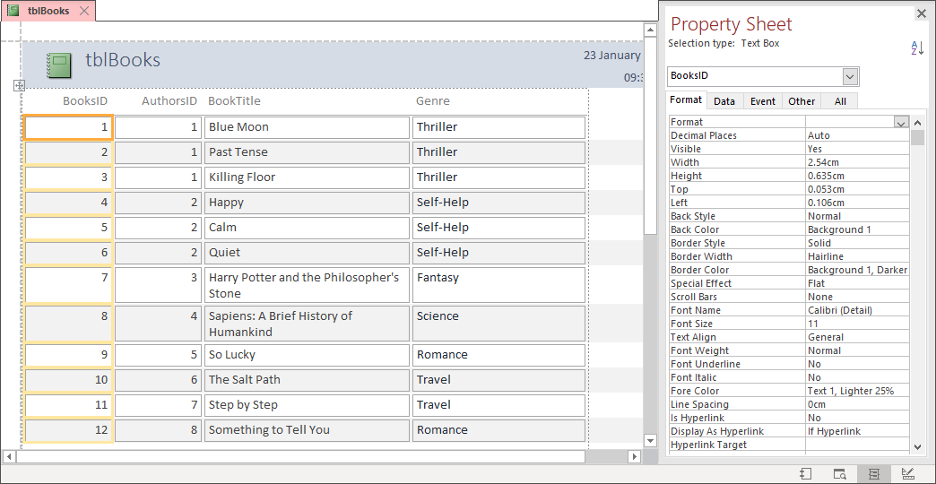

Practical 23: Creating Tables and Queries in Design View
Aim: To create a table and a query in MS-Access using Design View for more control.
Software Required: MS-Access
Procedure:
- To Create a Table in Design View:
  - Go to the Create tab and click Table Design.
  - In the design grid, define each field on a new row.
  - In the Field Name column, enter the name (e.g., StudentID).
  - In the Data Type column, select the type (e.g., AutoNumber, Short Text, Number).
  - Select the StudentID row, and on the Table Design tab, click Primary Key.
  - Save the table.
- To Create a Query in Design View:
  - Go to the Create tab and click Query Design.
  - A Show Table dialogue will appear. Select the table you want to query, click Add, then close the dialogue.
  - In the top pane, you will see your table's fields. Double-click on the fields you want to include in your query results (e.g., StudentName, Course). They will appear in the grid below.
  - In the Criteria row under the Course field, type "B.Tech CSE". This will filter the query to only show students in that course.
  - Click the Run button (a red exclamation mark) to see the query results.
  - Save the query.
Output:
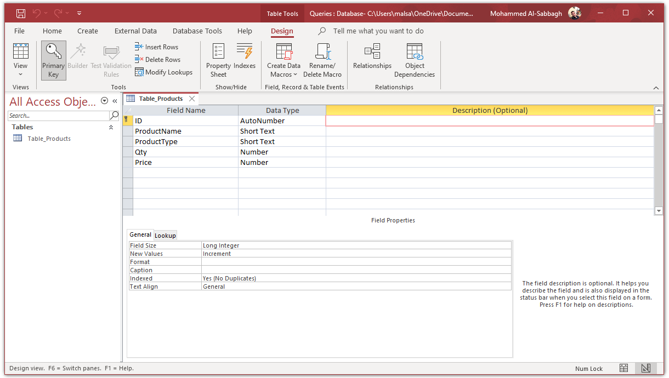

Practical 24: Creating a Data Access Page
Aim: To create a Data Access Page in MS-Access.
Software Required: MS-Access (Note: This is a legacy feature, primarily available in older versions like Access 2003/2007. It is not supported in modern versions.)
Procedure (for older versions of Access):
- Open your database.
- Go to the Create tab.
- In the Forms (or a dedicated Pages) group, look for an option called Page Wizard or Data Access Page.
- Click Page Wizard.
- In the first step of the wizard, choose the table or query that has the data you want to display on the page. Select the fields you want to include. Click Next.
- The wizard may ask if you want any grouping levels. This is optional. Click Next.
- The wizard may ask for a sort order. This is also optional. Click Next.
- Finally, give your page a title and choose to open it. Click Finish.
- The wizard will create an HTML file that is linked to your database, which can be viewed in a web browser.
- Save the page.
Output:
